PROBLEM DEFINITION
In this exam, you will help farmers having a rectangular shaped field (Width x Length) who want to partition this field according to some fixed configuration considering the type of the plant. The aim here is to reduce the area which does not belong any partition. For example, let our farmers have a field of (7 x 10) and the smallest area needed for a group of plant might be (6 x 5) and (1 x 9) for another group. They can use the same group more than once. However, the width and the length is fixed for a group of plant considering the watering and optimal case for sunlight etc. In other words, an area for a plant is not open to rotation.
What is the minimum area wasted by not planting anything? An optimal solution can be seen as:
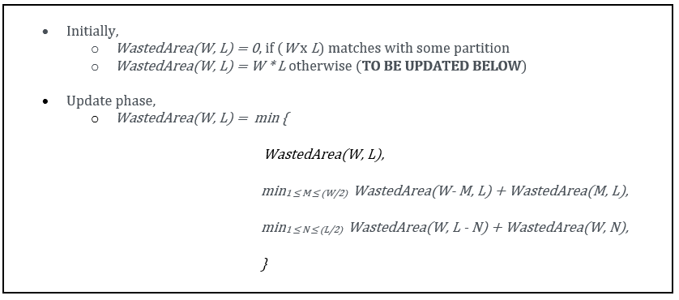
In general case, the solution can be found searching through possible cuts for partitions both vertically and horizontally. Here is the guide for computation:
Notice that in the search of possible cuts, we go through the half of the edges since the results are symmetrical in our case. This will not be applied in bottom-up solution. That is, we will construct the solution for all of the edges in bottom-up approach.

